**DEPARTMENT OF CHEMISTRY**

**QUIZ COMPETITION 2018-2019**

**TOPIC : NANOMATERIALS**

**GROUP: MBZC& BZC II YEAR**

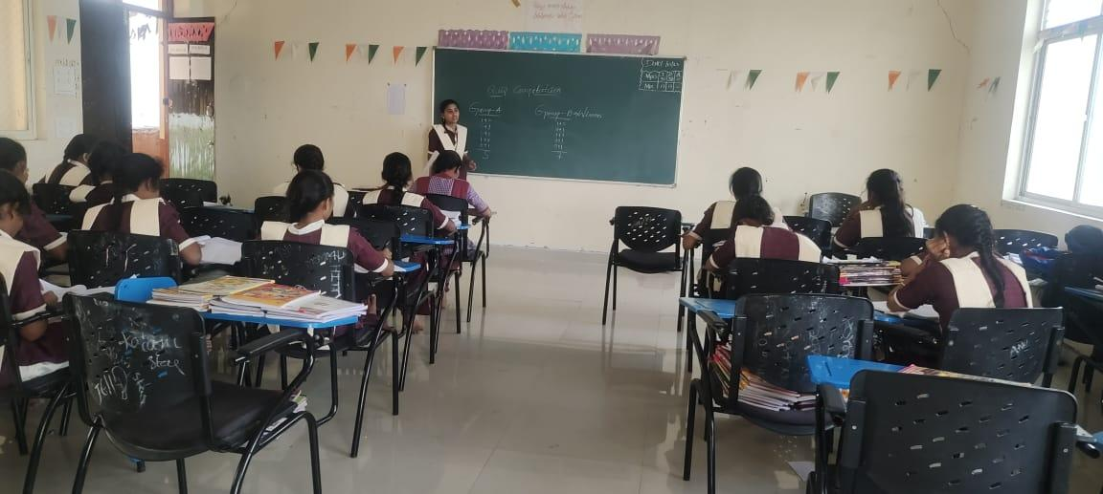

**ACADEMIC YEAR 2019-2020**

**TOPIC: CARBONYL COMPOUNDS**

**GROUP: BZC &MBZC II YEAR**

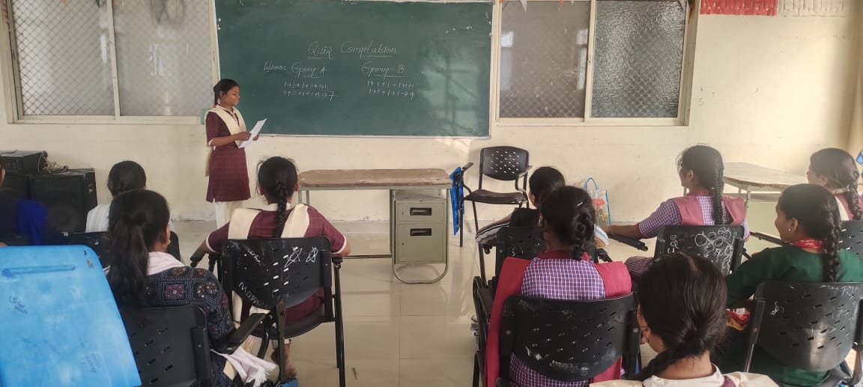

**ACADEMIC YEAR 2020-2021**

**TOPIC OF:  PHOTOCHEMISTRY**

**GROUP:MBZC& BZC**

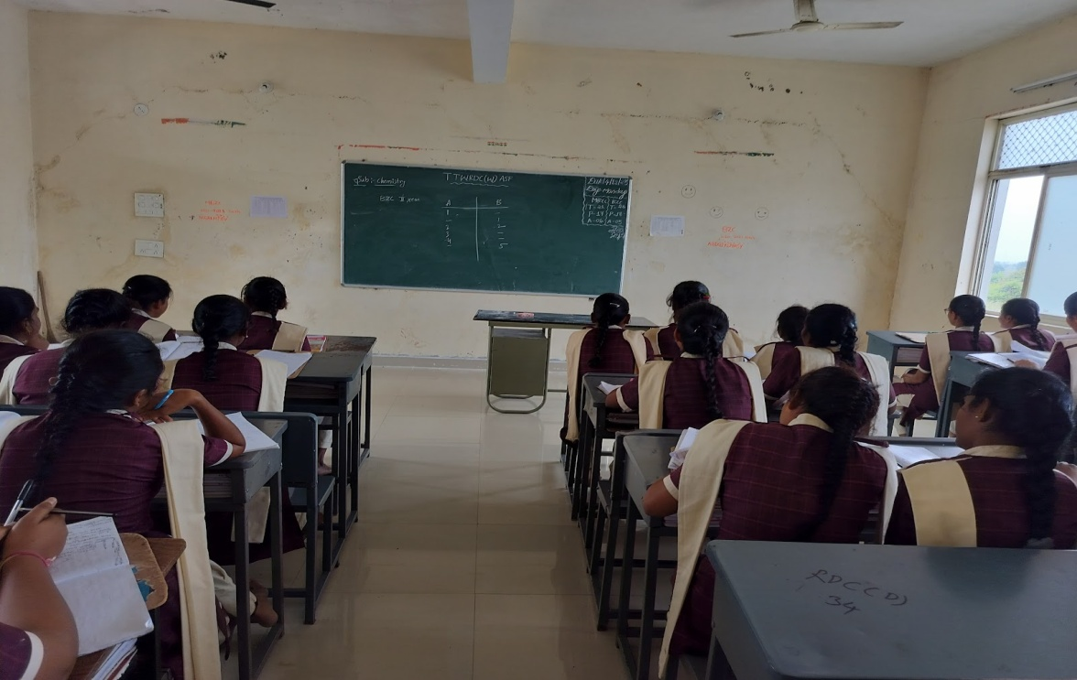

**ACADEMIC YEAR 2021-2022**

**TOPIC NAME:CHEMICAL KINETICS**

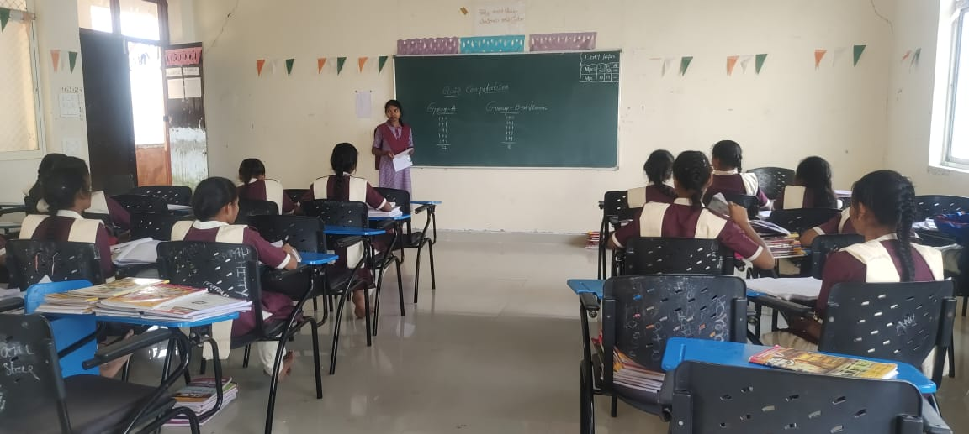

**ACADEMIC YEAR 2022-2023**

**TOPIC NAME: PERICYCLIC REACTIONS**

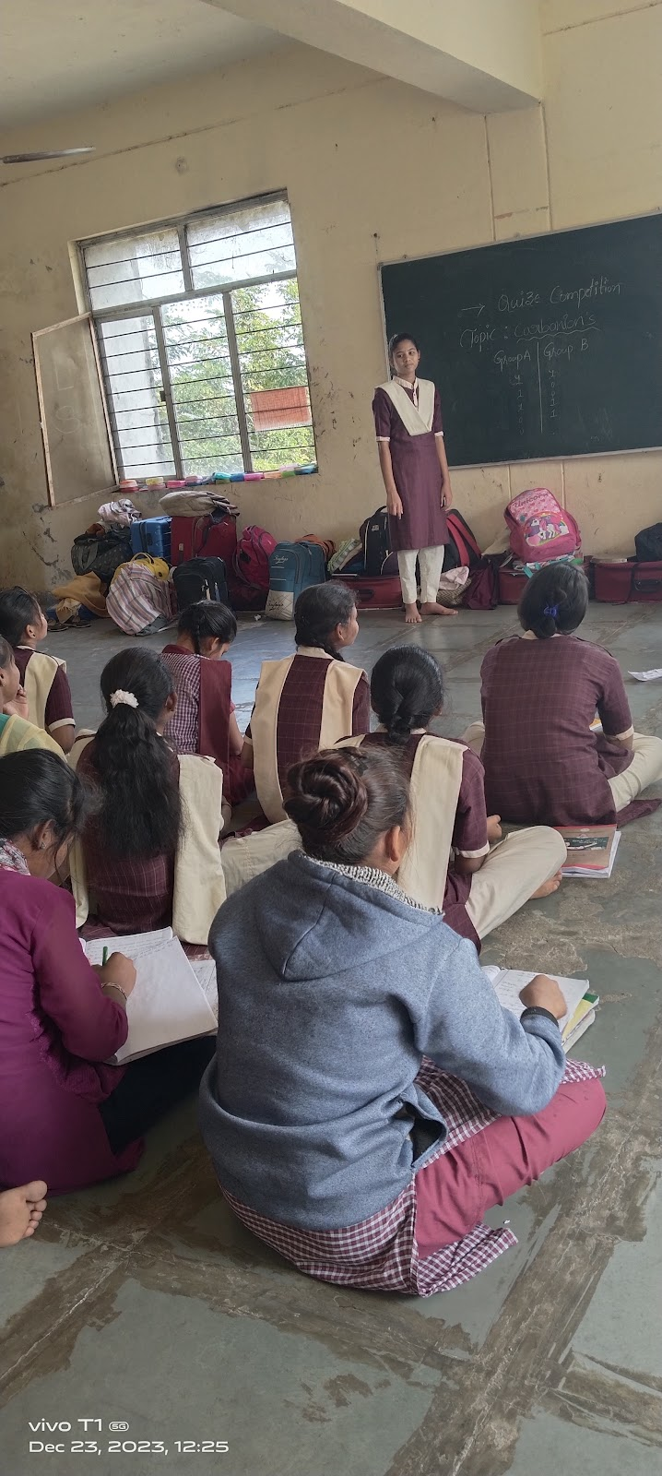

**ACTIVITY: DEBATE COMPETITIO**

**TOPIC OF THE DEBATE: PLASTICS AND POLYMERS**

GROUP : MPC &BZC IIYEAR

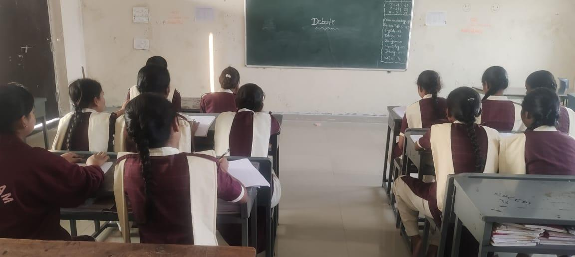

**NAME OF THE ACTIVITY:  GROUP DISCUSSION**

**ACADEMIC YEAR 2019-2020**

**TOPIC:  S and P BLOCK ELEMENTS**

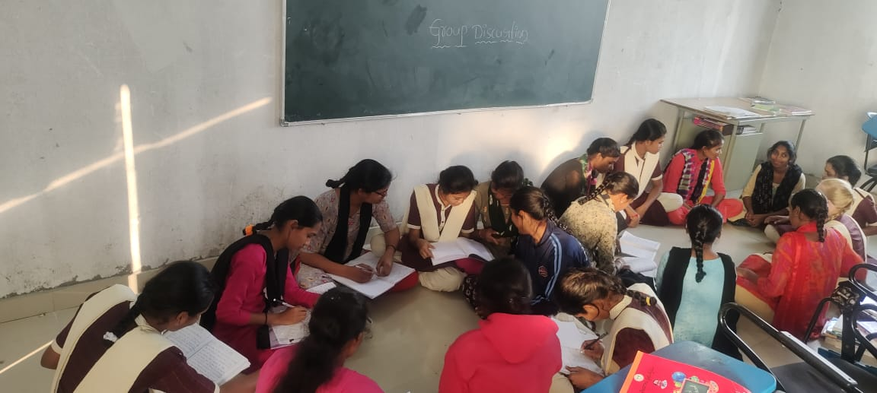

**ACADEMIC YEAR 2021-2022**

**TOPIC :    BIO INORGANIC CHEMISTRY**

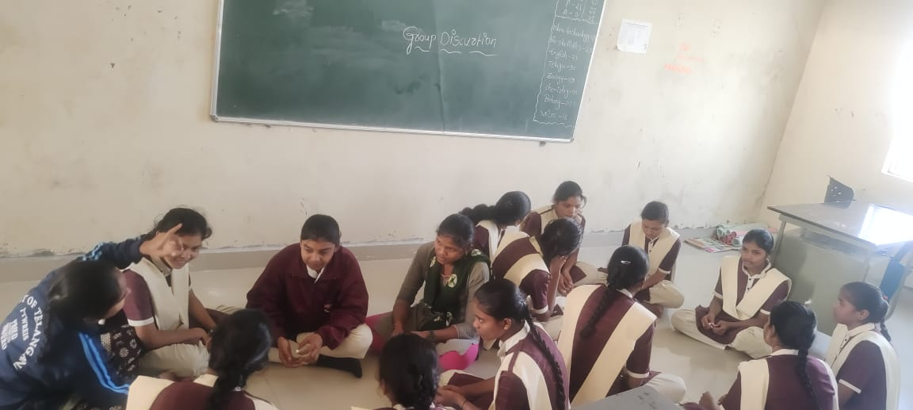

**ACADEMIC YEAR 2022-2023**

**TOPIC OF:   INORGANIC REACTION MECHANISMS**

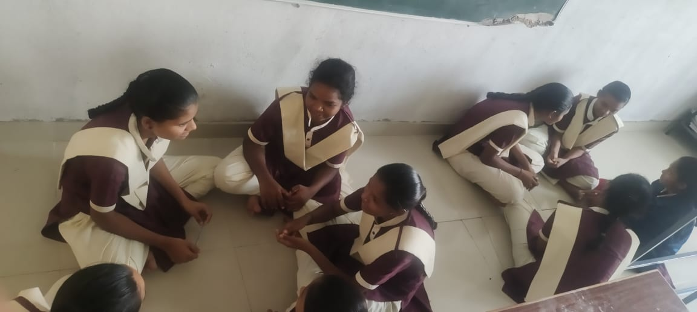

**DEBATE COMPETITION**

**ACADEMIC YEAR : 2018- 2019**

**TOPIC NAME: BIOCHEMISTRY**

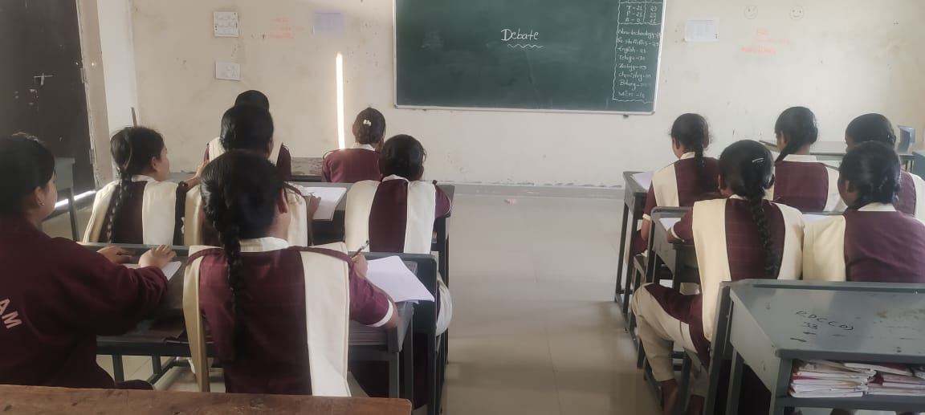

**ACADEMIC YEAR: 2019- 2020**

**TOPIC NAME: GENERAL CHEMISTRY**



